**Global Wader** Tracking Data Project: Data agreement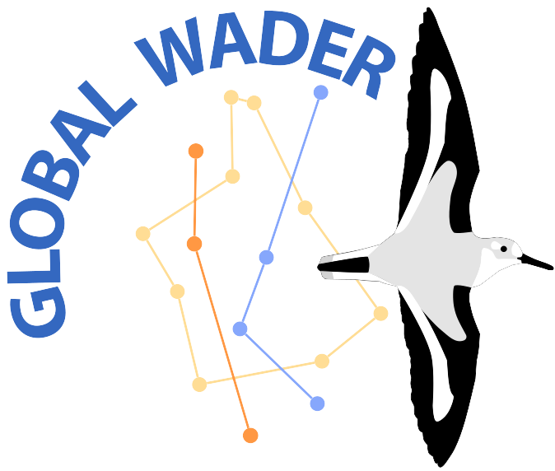

How the Global Wader Tracking Data Project can view, use and share results from your tracking project.

This form has five sections:

1. Basic study information

2. Data access

3. Sharing low-level summaries

4. Collaborations

5. Long-term management

Results will be stored internally by Global Wader in a password-protected area, and used only for project administration in accordance with permissions granted below.

**Please mark your choices with (X).**

* Mandatory answer

# Basic study information

1. Email*:
2. Contact name*:
3. If you wish to provide **your backup contact details** (e.g. personal rather than institutional email) for the long run, please do so here:
4. Study name (**use the same as in Movebank** if applicable), brief description (e.g. Movebank 'study summary') and link(s) to dataset(s)*:
5. Does this data agreement replace a previous one?

*Please select ‘Yes’ if you have previously filled a Global Wader Data Agreement about this study.*

( ) Yes

# Data access: how much information can Global Wader see from your project?

*If you wish to share Movebank data with Global Wader, you can add our username 'gwtdp' to the study as a "Data Manager" or "Collaborator". (Note that permission to* ***download*** *data is necessary for any analysis to be undertaken. Such permission can be granted following "Share>Permissions" in the study page, then tick "Restrict data downloads to" and select the type of user that Global Wader is in your study.)*

*To increase the discoverability of your study, you may wish to add the text "This study is participating in the Global Wader tracking data project:* [*http://www.globalwader.org/*](http://www.globalwader.org/)*".*

1. For studies archived on Movebank:

*For more information on Movebank permissions settings, and how to alter them, see* [*this guide*](https://www.movebank.org/cms/movebank-content/permissions-and-sharing)*.*

( ) The data is published openly (e.g. under a CC-BY licence) - anybody can view & download data

( ) The data are not open, but Global Wader is included as a Data Manager - Global Wader can view, download, upload and edit data

( ) The data are not open, but Global Wader is included as a Collaborator - Global Wader can view and download data

( ) The data are not open, and Global Wader has the same level of access as other registered users

( ) NA - the study is not on Movebank

1. For studies archived elsewhere (i.e., not Movebank):

( ) The data is published openly (e.g. under a CC-BY licence) - anybody can view & download data

( ) The data is not published openly, but we will share access with Global Wader

( ) The data is not published openly, and we will not share access with Global Wader

( ) NA - either the study is on Movebank, or it has not been archived

1. For studies that have not been archived (or not on Movebank):

( ) We would like to submit summary information about the project to Global Wader

( ) We would like to archive the data in a repository, and would like to be contacted by Global Wader for assistance

( ) We do not wish to be contacted about this study, nor to share information with Global Wader

1. Can Global Wader contact you about this dataset?*

*We may wish to contact you, for example:*

* *to notify you of a proposed collaboration*
* *to clarify an apparent error or omission in the data or documentation*

( ) Yes

( ) No

1. If you have any comments or questions about sharing data with Global Wader, please add them here:

# Sharing low-level summaries

*Global Wader would like to process studies to which we have access, in order to produce 'low- level summaries' of the data that can be easily combined or compared with other studies. These may include:*

* *Using a low-resolution global grid to plot the global availability of tracking data (see https://*[*www.globalwader.org/data)*](http://www.globalwader.org/maps))
* *Generating estimates of tracking-data availability according to species, year or stage of the annual cycle*

*These summaries may be useful for running the project, for instance:*

* *Displaying maps or other statistics on our website, presentations or other promotional material, to give an overview of the project's coverage and development*
* *Answering enquiries from potential collaborators, e.g. "What tracking data is available from X estuary?"; "Where has species Y been tracked?"*

*These data will not be shared outside Global Wader, nor used for academic publications, unless you consent below.*

1. Can Global Wader process, store and use low-level summary information about your project, as described above?*

( ) Yes

( ) No

1. Do you additionally grant permission for the low-level summary information described above to be potentially used in academic publications about the Global Wader, without further contact?

( ) Yes

( ) No - please contact first

# Collaborations

*A major goal of Global Wader is to facilitate the re-use of collected tracking data in collaborative studies. These might include:*

* *studies focused on particular geographical areas, e.g. in the context of developing local management plans or environmental impact assessments;*
* *comparisons amongst different populations of the same species;*
* *comparisons amongst multiple species inhabiting the same area.*

*Where GWTDP has access to non-open data, we would be like to be able to inform potential collaborators that your study might contain relevant information, e.g. from checking the low-level summary information above.*

*Note that the* [*Movebank Terms of Use*](https://www.movebank.org/cms/movebank-content/general-movebank-terms-of-use) *place the following responsibilities on collaborators: "For studies that are publicly downloadable and have* [*CC0*](https://creativecommons.org/publicdomain/zero/1.0/)*,* [*CC BY*](https://creativecommons.org/licenses/by/4.0/) *or* [*CC BY-NC*](https://creativecommons.org/licenses/by-nc/2.0/) *licenses, permission of the owner is not required for use. However if data will be used for new applications or analyses, we strongly encourage users to make a reasonable attempt to contact these owners about your intended use, and to offer co-authorship or other credit as appropriate for publications or products resulting from the use of these data." Global Wader expects all our collaborators to abide by the same principle.*

1. Would you like Global Wader to share information about your study with potential collaborators?*

( ) Yes - my data is open and can be used (and cited, where appropriate)

( ) Yes - we are happy for summary information about the project to be shared.

Collaborators can then contact us.

( ) Maybe - please contact us first, before sharing any information about the study

( ) No - we do not want to share any information about the study with anybody

1. Do you wish to add anything about potential Collaborations and Publications? (E.g. "for conservation purposes the data can be used freely.")

# Long-term management

*Data archived in repositories are intended to be usable for tens - maybe hundreds! - of years. We therefore recommend that studies* ***not*** *currently published openly do two things to reduce the risk of your valuable tracking data becoming permanently inaccessible:*

1. *Set an* ***embargo date****. This is a future date (up to 10 years in the future) when work on the project is expected to be finished and published. At this point, the data automatically become open to all. The process is fairly simple, and explained* [*here*](https://www.movebank.org/cms/movebank-content/permissions-and-sharing)*.*
2. *Provide* ***alternative contacts****. This can be achieved by adding additional Movebank accounts as Data Managers (see* [*here*](https://www.movebank.org/cms/movebank-content/permissions-and-sharing)*), and/or providing Global Wader with the name and contact of at least one other person to operate as a backup.*

*This is because, in 10 years or more, you might have changed your email, your job or simply decided to focus your time and energy elsewhere.*

1. Have you set an embargo date for your data?*

( ) My data is open, so no embargo is needed

( ) My data is currently not open, but I have set an embargo (please specify below, if you wish)

( ) My data is currently not open, and I am not interested in setting one - I assume the risk of my data becoming inaccessible if I can no longer log into Movebank

1. If you have set an embargo, or have questions about doing so, please fill them below:
2. **With their permission**, please suggest the name and contact of one or more people/institutions to act as alternative contacts, in case you cannot be reached for a long period (typically several months):
3. Finally, is there anything else you would like to add?